June 22 - June 26 (Mon-Fri clas[s](https://meet.wellsfargo.com/linda.dixson/V2L1HHD9?sl=1))

**Intro to Angular**

SSA

**Instructor**: Judy Lipinski

[judy@karmoxie.com](mailto:judy@karmoxie.com)

<https://www.linkedin.com/in/judylipinski/>

Open Solution to 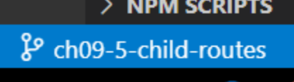

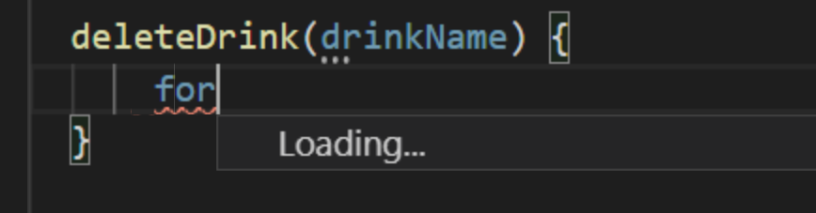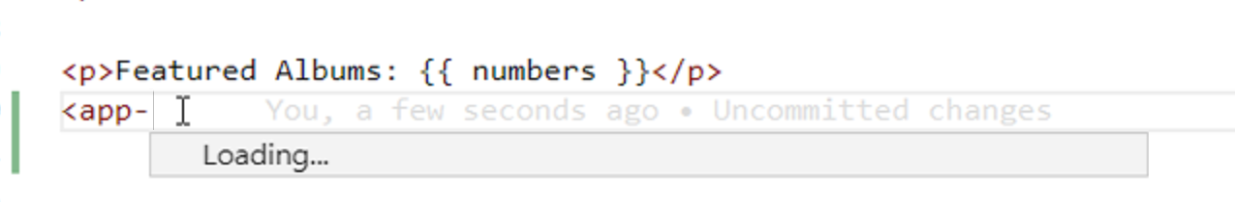

# 

# 

# In Class Links

* [**the virtual machine assignments**](https://docs.google.com/spreadsheets/d/1GCVh2kYGyYuYMN97fbJwc2MVDCxcTwKr1JR8zMn-Mmg/edit#gid=0) **spreadsheet**
* **This doc** [**http://moxie.pro/2020june22ng**](http://moxie.pro/2020june22ng)
* Copy/Paste from host to remote
  + (toggle menu with control+shift+alt)
* Added everyone to the repo
* Use **git clone** for each of these when at work or on personal machine
  + <https://github.com/JudyLipinski/angular100-labs-2020-06-22>
  + <https://github.com/JudyLipinski/angular100-demos-2020-06-22>
  + <https://github.com/JudyLipinski/angular100-solutions-2020-06-22> 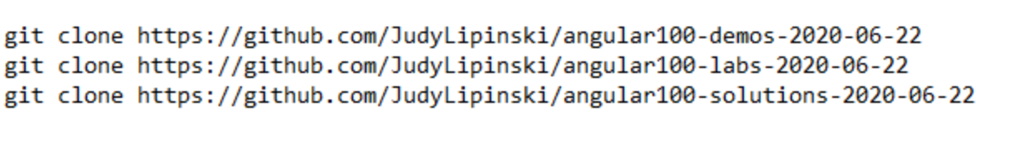
    - in projects run:
      * ng update @angular/core@8 @angular/cli@8
  + Accept from the email that is with your github
  + You click accept - but you get a 404 if not logged in to github
  + Their method of security!
  + So log in, THEN click the email again

# Chapter List

[**1 Overview of Course and Angular Development**](https://docs.google.com/presentation/d/e/2PACX-1vRa09NPuxSQUOJS9e4bxPd9tTXcXMffYoU_by8gpCSwSAV-IH2J0Qsu2I2R97658UbR6yZSeWhJ6oM7/pub?start=false&loop=false&delayms=3000)

[**2 Creating and Exploring Angular Projects**](https://docs.google.com/presentation/d/e/2PACX-1vThfMXGZdx0IUQJO7hsELGI45TXNpZPBcAJTNnXdihL7oSRUA2xrEpyWBCLv9CmO910UUuMNL8lbI4_/pub?start=false&loop=false&delayms=3000)

[**3 Data Binding in Components**](https://docs.google.com/presentation/d/e/2PACX-1vSxMHnb4n_mgttstyuYkvMdFZG98DHWBgBhpkblTikSTFLACkdMJqgGjOBZ_0oh1I2N_zpp3MeCd3e4/pub?start=false&loop=false&delayms=3000)

[**4 Passing Data & Event Binding**](https://docs.google.com/presentation/d/e/2PACX-1vSa47fAF0urZVCcz_HHKa60luV-yzguMYBji0lWOaDYeq-YWje0olCiyrdgjKBieN9SY1JWay9z10-s/pub?start=false&loop=false&delayms=3000)

[**5 Using Directives**](https://docs.google.com/presentation/d/e/2PACX-1vR055PAjjVep7vTlC30l-LTAk2KK65ylKW1uYLr3uZxzBr1320-6yNeg_d34GW_bTMZsKVFXSC3Ra93/pub?start=false&loop=false&delayms=3000)

[**6 Using and Creating Pipes**](https://docs.google.com/presentation/d/e/2PACX-1vQwNZE_oir_whJIwmMu-XUJMCbXazexBZZBRHpsr62NmkXLaqQiBpWZZI8KDrhVpFLpf_4tMaTPNNVR/pub?start=false&loop=false&delayms=3000)

[**7 Understanding Change Detection and Lifecycle hooks**](https://docs.google.com/presentation/d/e/2PACX-1vSgZZAuipN5mso_hhKRyquSzYkymv4QyIktK89Hpuln_zrtG1XR6bQtWEKSUF3f_4NWkqTPOTlK13hI/pub?start=false&loop=false&delayms=3000)

[**8 Services, HttpClient and Observables**](https://docs.google.com/presentation/d/e/2PACX-1vSDrFLTozxJS74CRuasJICuTf5pgyih9_HvrW5sqK6OStZaVcEuqp-G-HH1PcJ1sg-PJIpuT-x19O8E/pub?start=false&loop=false&delayms=3000)

[**9 Leveraging Routing Features**](https://docs.google.com/presentation/d/e/2PACX-1vQYAb4N1Phggpk5E--_5TZk3aqbE75HR1c6csvQ7N10NPBK7FOdJraYV1Jqz6fG5xwOmPvN6zyWKtkC/pub?start=false&loop=false&delayms=3000)

[**10 Working with Forms**](https://docs.google.com/presentation/d/e/2PACX-1vQnquKXsRPI2wRWpUYXkYJngbNS5et9q9XWNjY2Uaw5tIDLNBfECc3O9xefa-_FZZpewjFazgiVoPD1/pub?start=false&loop=false&delayms=3000)

[**11 Unit Testing in Angular**](https://docs.google.com/presentation/d/e/2PACX-1vQ77QDzfnYAB7BnEQGypeko8oCuvn24kPMSixby096xHLXrDa2C8YDmCu0_OeY0jGsJEd1_1pNPTqtR/pub?start=false&loop=false&delayms=3000)

[**13 Summary**](https://docs.google.com/presentation/d/e/2PACX-1vT1Ag7Z3geuqgXq4091t5cJPyTo1gl1mOGAZqU13rWSY6X7jO1mEvPdYWU4fbrpWf7mLYDJKFgx98kp/pub?start=false&loop=false&delayms=3000)

# Creating Project in angular100-labs

* delete gitignore and outer README from root directory
* ng new my-angular-albums --directory ./

# 

# 

# Parking Lot:

* how to clear history of an active terminal in vs code
* deployment of Angular - devops

Music Requests:

* classical study music <https://www.youtube.com/watch?v=BMuknRb7woc&list=RDGMhIT4a98UE&index=3>
* vitamin string quartet

# Tech Resources:

* Forms



* Routing

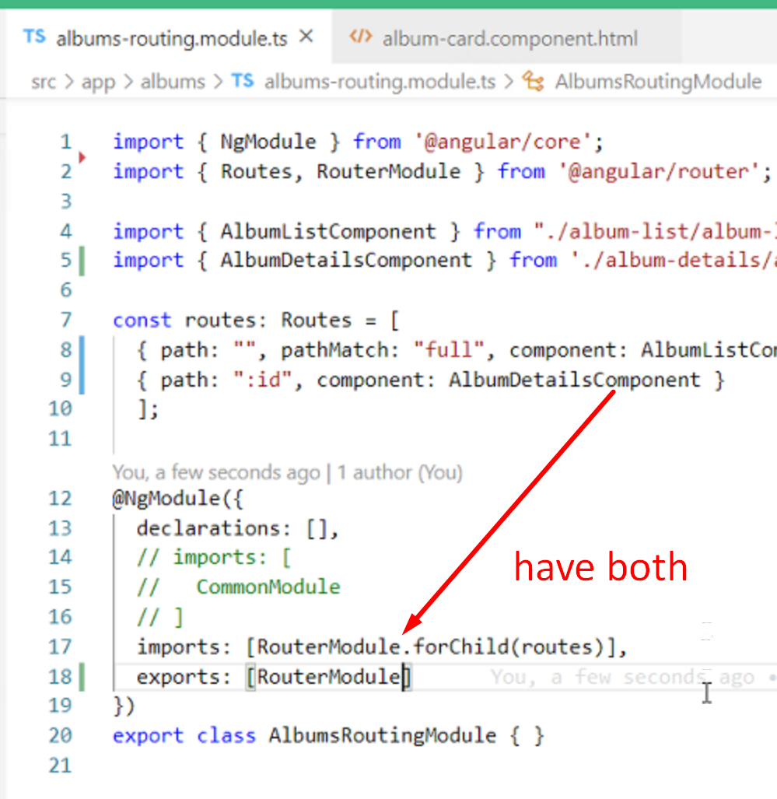

* Snipping tools
  + Lightshot <https://app.prntscr.com/en/download.html>
  + Sketch? mac
* RARELY but sometimes, you will get an error in Angular project. What I have found fixes this is to delete the node_modules folder and npm i. Sometimes i have had to delete the node_modules cache as well. npm delete cache?

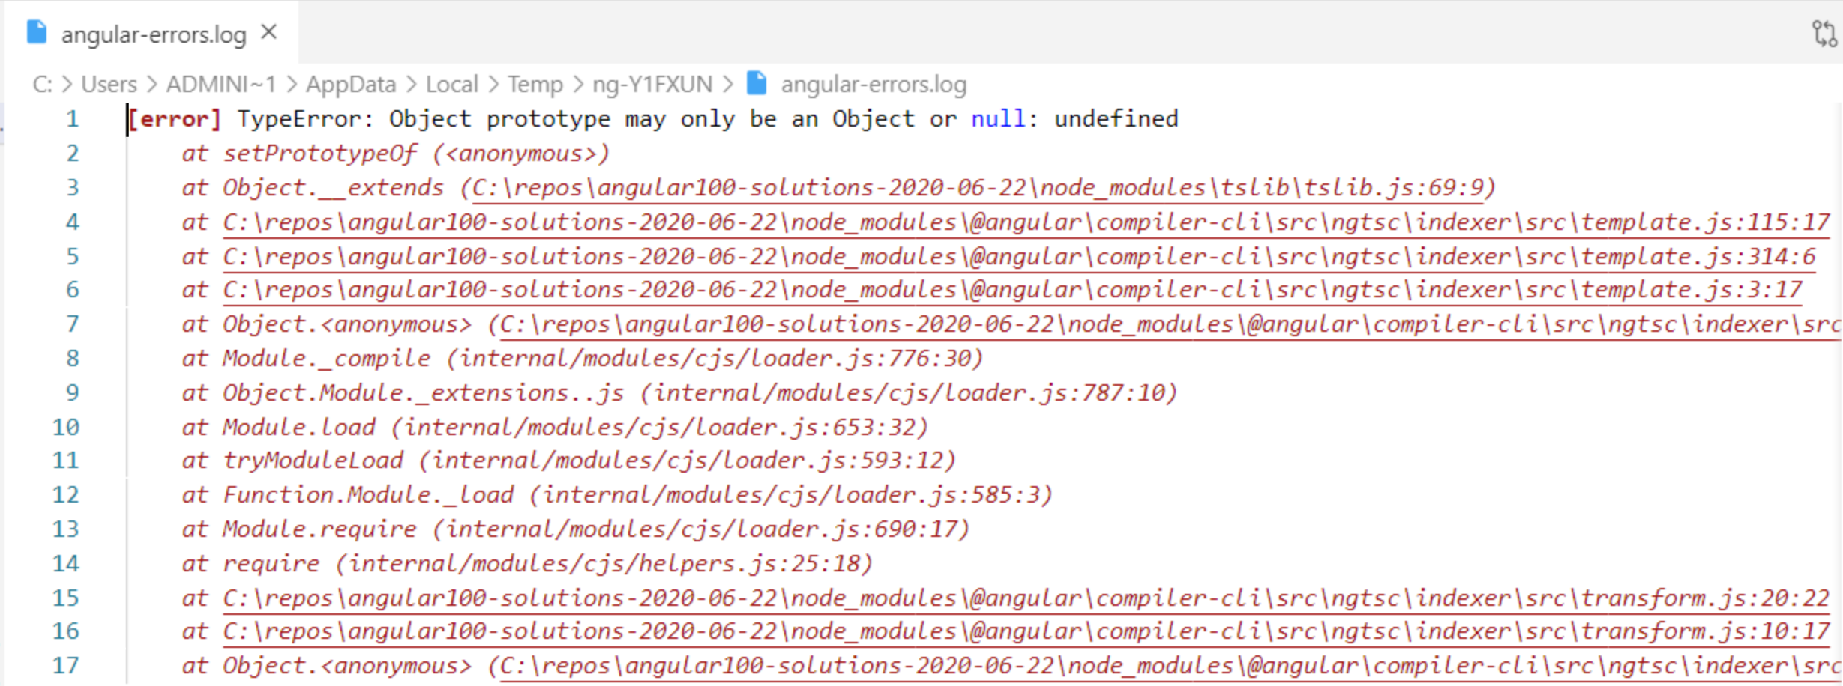

if deleting node modules and npm i still doesnt work still

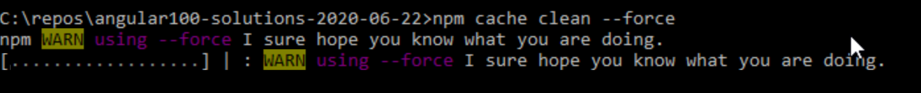

if that doesn’t work - try upgrading angular

ng update @angular/core@8 @angular/cli@8

* browsermodule contains commonmodule
  + exports commonmodule gives us the directive of *ngFor, *ngIf

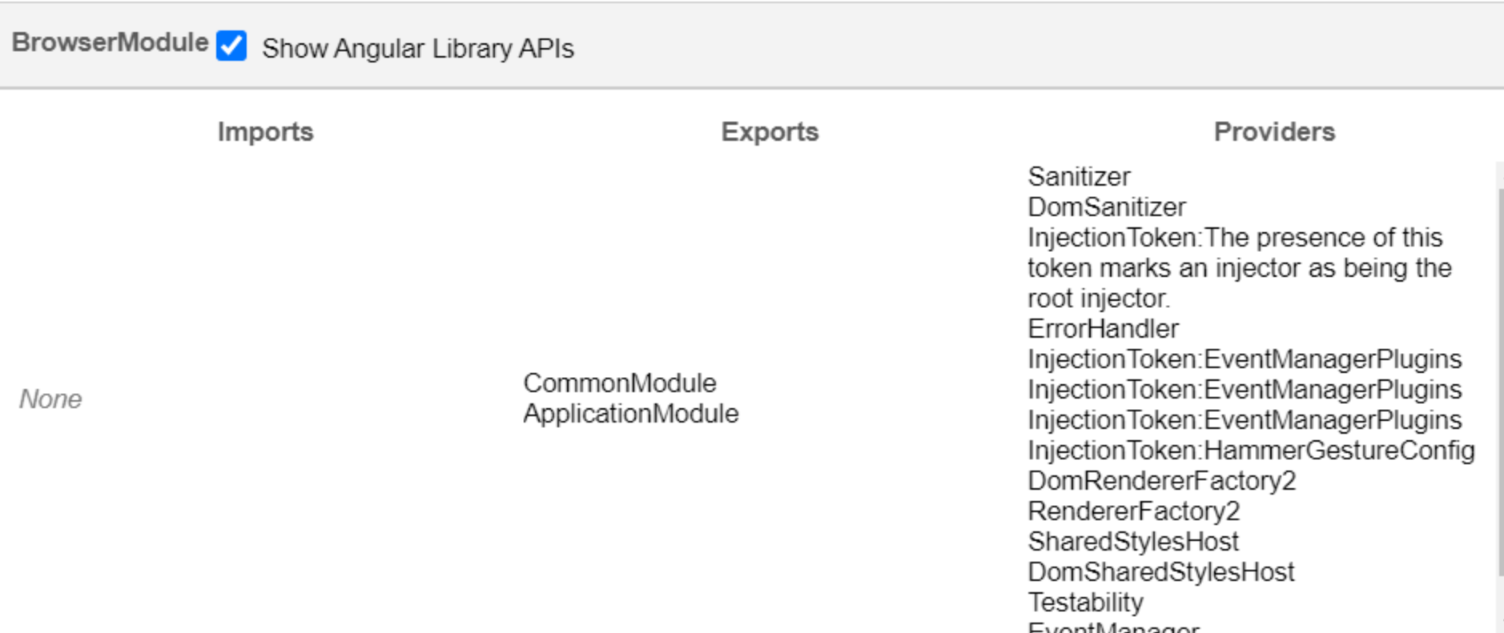

# Other notes:

Block Coding: code.org, Scratch

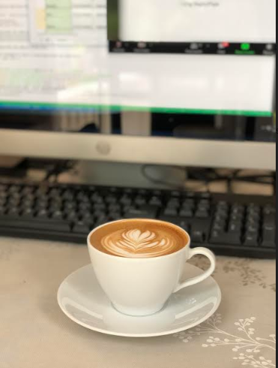

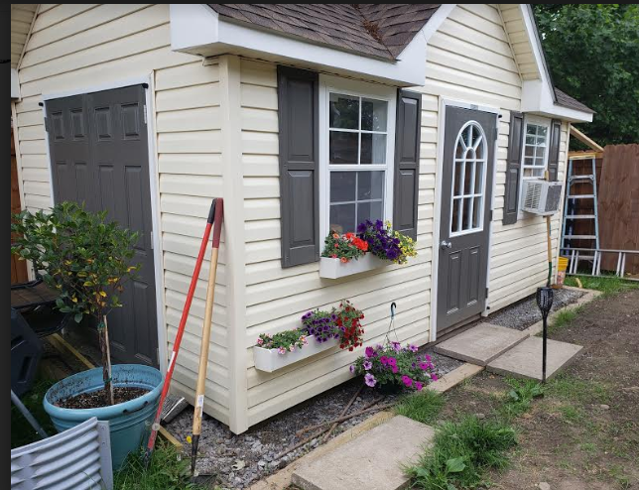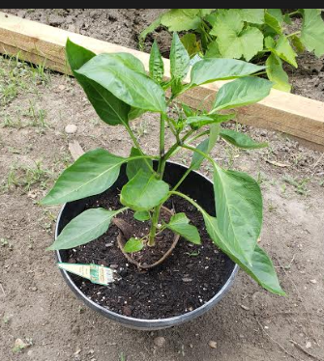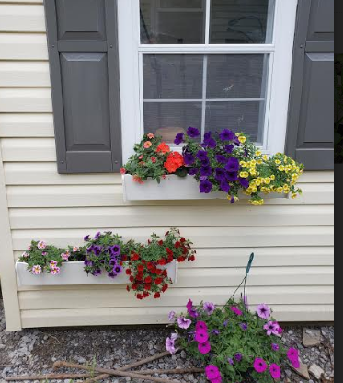

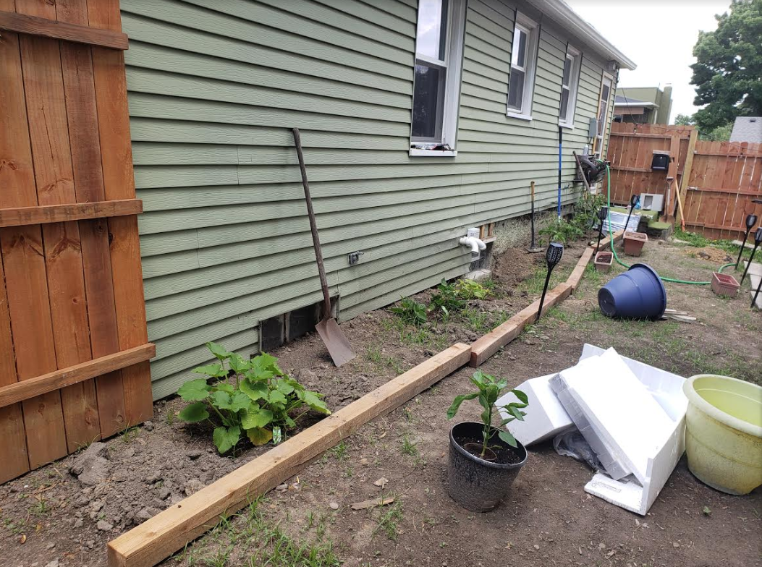







<https://photos.google.com/share/AF1QipNmRtkJRMxP64vzTkH7PyyX6Ml65XnPBjyf5WHZkkqVehy-YqDMDXs0AdqhaR0UDw?key=dXcxbDcyeFdicmdQX244UzhhenBvdDN5QmRIZUd3>

Click to see these and more

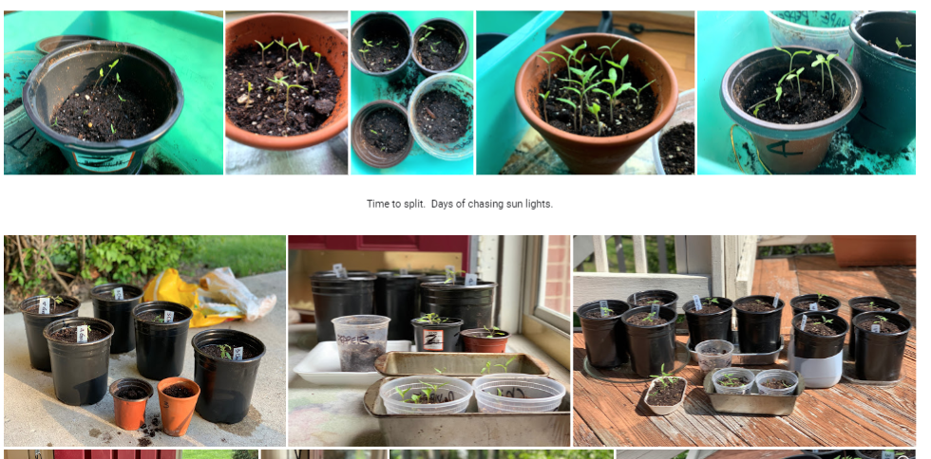

# Daily Review:

* what was new / helpful yesterday?
* do you have any questions?

Fri am

* Routing
  + AppRoutingModule
    - thats where URL mapping lives (Routes)
    - load either component (lines 9 ad 10)
    - OR line 15 is an example of LAZY LOADING

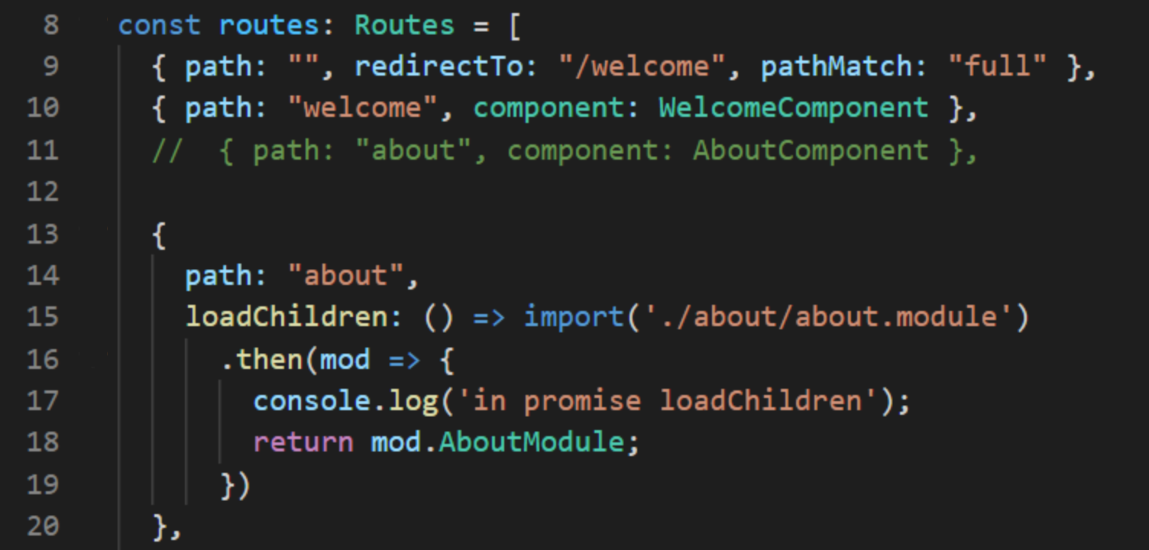

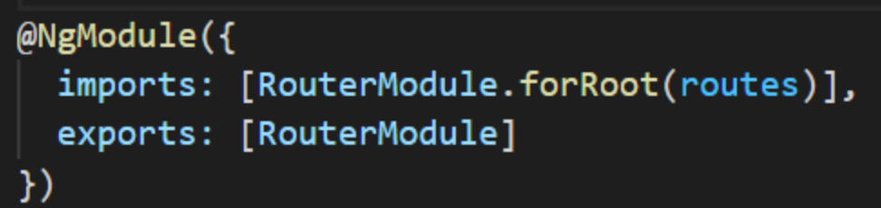

* Lazy Loading - those feature modules have their OWN Routing Module
  + Uses forChild to lazily load the additional routes
    - appended to whatever base route was in AppRoutingModule
    - at that point the JavaScript for THAT lazy loaded module will be obtained from backend (JS file)

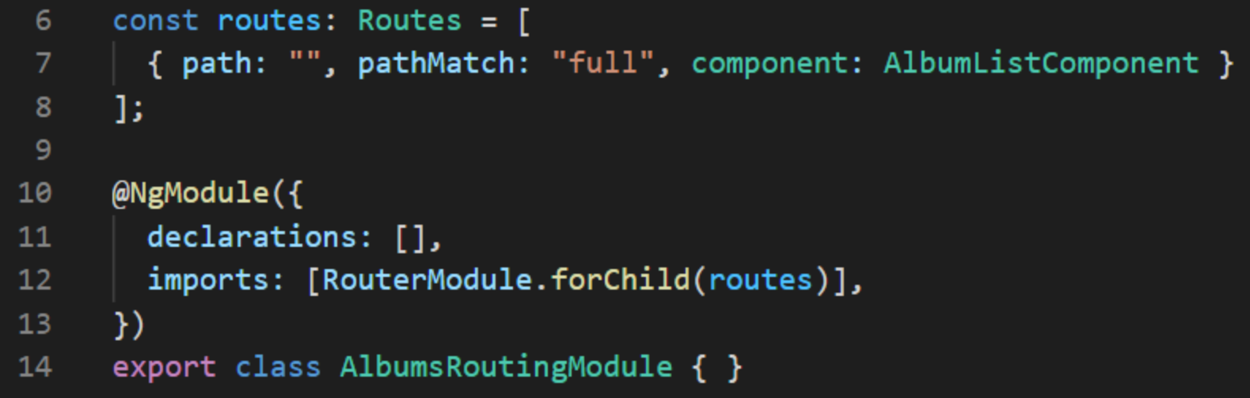

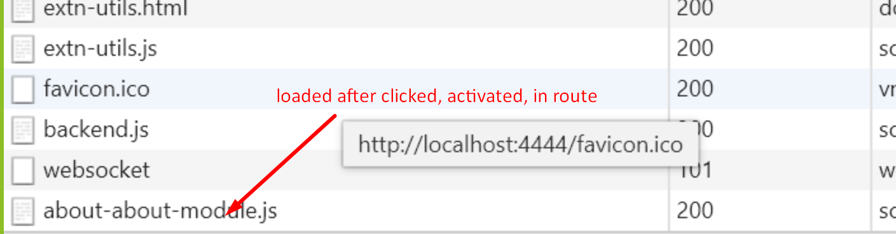

* Services
  + functions that can be shared among your components
  + How does dependency injection work in Angular?
    - use constructor - indicate it receives the service
  + How in constructor do we auto generate properties?
    - use public, private or protected keywords - to generate automatically
    - What is the reason to do this in Angular?
      * constructor(**private** hideData : HideData) { }
      * constructor(**public** hideData : HideData) { }
* Observables
  + using subscribe - initiates async calls
    - pass an object that contains our callbacks: **next**, **catch**, **complete**
    - OR pass callback directly in the above order
  + unlike Promises
    - observables can be cancelled!
    - can continue to return values over time don’t have to!)
    - they are LAZY - not executed until we subscribe
  + pipe allows us to indicate operations to perform on Observables
  + a lot of the Angular API - return Observables
    - including HttpClient
* HttpClient
  + Need the HttpClientModule to be added
    - where do we add these?
    - root is a good place, to make available to components declared in AppModule
* Feature Module?
  + Can aligns with your major navigation of your app
    - Home, About, Products, **Claims**, Admin, Benefits
  + way to organize components - helps with overcrowding of AppModule
  + a custom module that is not the AppModule or built-in Angular Modules
    - Angular Modules: HttpClientModule, FormsModule, ReactiveFormsModule
  + what benefit is there in using a feature module?
    - lazy-loading!
  + re-use in other applications

Thurs am

* Angular event handling
  + <p (click)=”localFunction”>
  + <app-custom-comp (mouseover)=””>
* Passing Data from Parent to Child
  + Child receives data with @Input() prop
    - Passed from parent using <app-comp [prop]=”value>
  + Parent receives event notification
    - Child emits event - @Output() someEventEmitter
    - Parent listsend for event <app-comp (someEventEmitter)=”localFunction”>
* Structural Directives
  + *ngIf=”someVariable”, *ngFor=”let someVar of someCollection”
    - Will manipulate the DOM, adding to removing
    - They are re-evaluated during change detection
      * 3 triggers: interval/timeout, browser events, AJAX
* Pipes - can create your own custom
  + name is needed that is how it will be used

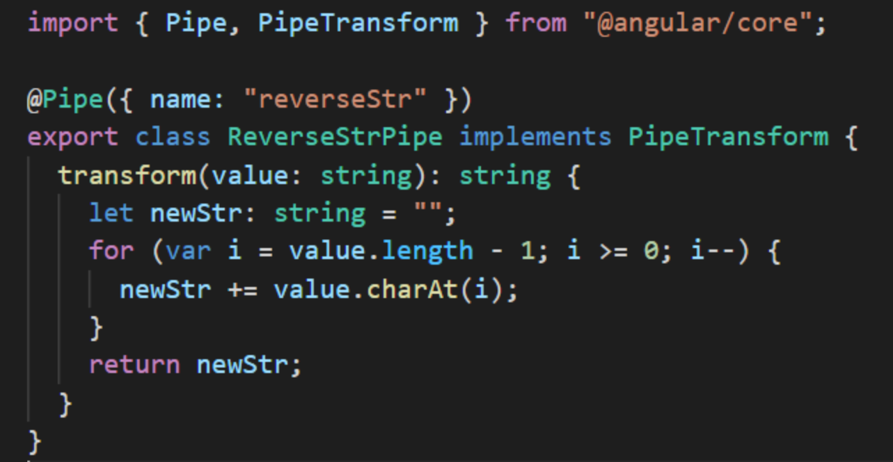

* 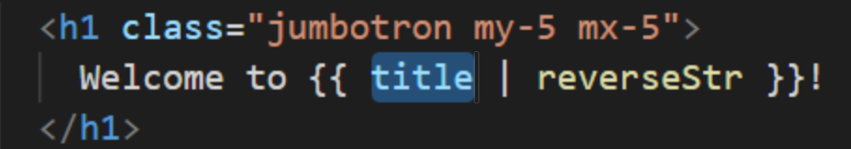

Wed am

* Using keyword **this** in JavaScript
  + Current object
  + Used in ES6 **classes** and constructor functions
  + In our Angular components, we have properties
    - In all functions we need to use **this.**property_name
* Spread operator
  + Can create something new using existing arrays or objects

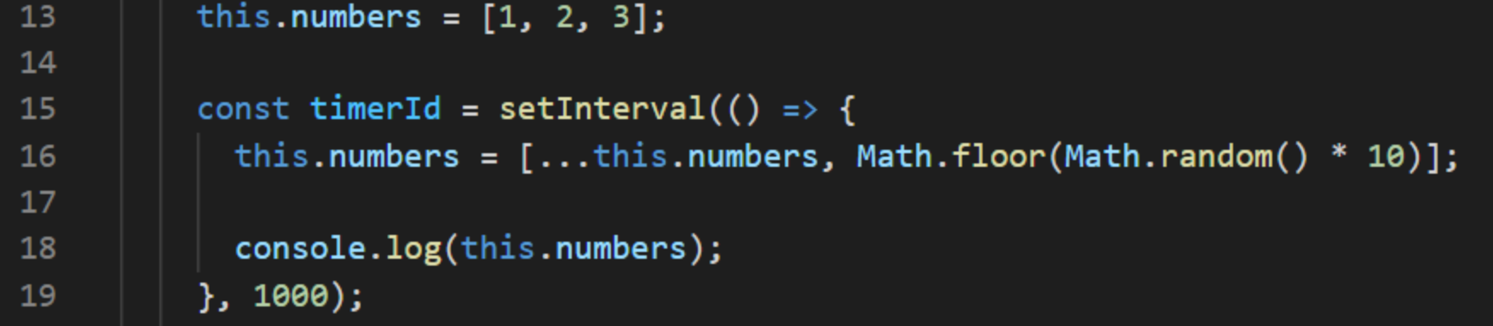

* + numbers starts out pointing to an array in memory
  + if we only modify this array - Angular does not update the screen
    - ex. numbers.push(12) - the screen will not update
    - Angular wants to see a new reference - not the same object being modified
  + SPREAD OPERATOR is used to create a brand new object (array)
    - this.numbers = [...this.numbers]
      * this creates a new array!
      * using square brackets [ ] or new Array - gives back a new array
    - NOW - Angular will update the screen with the new array
    - in this case, because using the same variable again this.numbers
      * the old array in memory - becomes dereferenced - avail for garbage collection
  + Can also use Spread operator with objects
    - let person = {name: ‘Tom’, email: ‘tom@gmail.com’}
    - let person2 = {...person, phone: ‘412-609-1036’}
      * a 2nd objects is created, with all properties from 1st object copied
* Angular is an entire framework
  + it gives us a standardized way of approaching the structure of our app
    - if using plain vanilla javascript - there is no structure
    - structure helps eliminate “spaghetti code”
  + it gives us APIs that we can leverage
    - for how to best update the DOM - when the data changes
    - we can create services for sharing logic between components
    - HttpClient - to make AJAX calls
    - Router - to create client side routing
    - ability to handle forms asynchronously
* Bootstrapping of Angular Application
  + index.html has references to main.js bundle added by Webpack
  + main is bootstrapping AppModule (aka Root Module)
  + AppModule bootstraps the root component (AppComponent)
* With an Angular project - you do not need to install anything else
  + Just npm install
  + The package.json dependencies include the angular packages
  + These include webpack and many other tools
* Using typescript we enforced type constraints
  + DO NOT USE CLASSES for type checking - use INTERFACES
  + Type checking is done at compile time
  + After the es5 code is generated there are no interfaces
  + If you were to use classes, everytime you call new that creates an object
    - If use classes instead of interfaces an obj is created taking up memory
  + Interfaces go away when compiled, so dont take up memory
  + Could indicate types in interface
  + When declare variables use colon to indicate type
    - person: Person
      * name: string
      * email: string
      * age?: number //use ? when optional
* 3 things that kick off change detection? (zone.js is used to rewrite internal JS of browser) - Angular then re-evaluates template expressions
  + timer functions (setInterval, setTimeout)
  + browser events (click, mouseover)
  + AJAX

Tues am

* JS demos was helpful
* VS Code features
* TypeScript
  + its ES6 + ability to add types
  + requires a build to create JS
  + constructor()
    - can use public/private - and that generates properties for you
    - constructor(name:string) {this.name = name}
    - constructor(private name:string) { }
* Branches
  + can use VS Code to switch, create branches